**Student: Park Jihye**

**Student ID: 2019313260**

**Course Section Number: SWE3048**

**WEB PROJECT**

**REPORT**

**[SKKU DIET PLANNER]**

# For All Users – Create an account & log in

## [Initial Page]



[Main Function]

* Select Login or Register: You can go to the login page or register page by clicking on the corresponding title(Login/Register).
* You can know the title of this project through the largest written Diet Planner
* The Login/Register title is decorated with a p tag in the div.

## [Register Page]

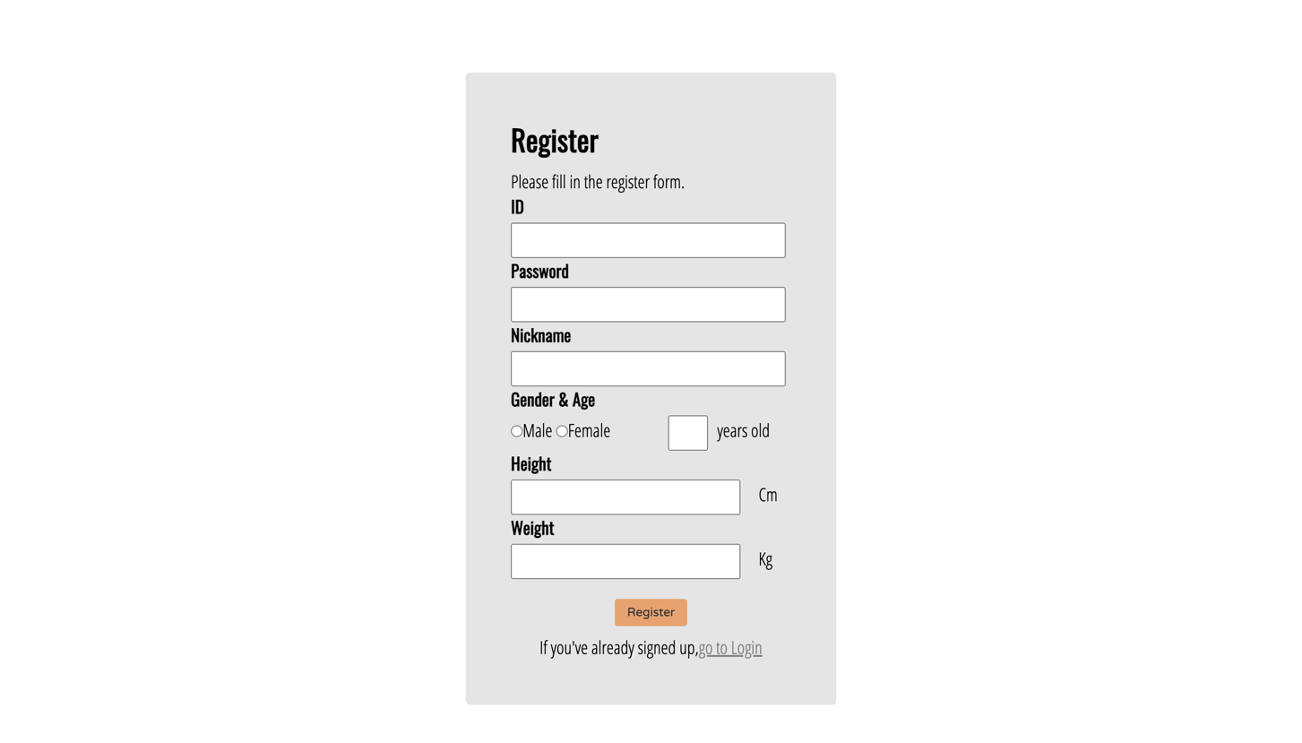

[Main Function]

* On the register page, the user can register a new account.
* Register title: This indicates that the page is a register page.
* Introduction to register method: You can see that you can register by filling in the given form.
* You have to write the following in order to register.
  1. ID: You have to create a new unique ID that has never been registered before. If this ID exists, there is a warning statement indicating that it already exists.
  2. password: your password must consist of at least one uppercase/case/number/special character and must consist of at least six characters. If not, there is a warning statement indicating that the password configuration is incorrect. It is okay to overlap with other accounts.
  3. Nickname: Construct a nickname for you to use comfortably. It is okay to overlap with other accounts.
  4. gender: Choose your gender.
  5. Age: Write down your age. Only numbers can be entered in this input.
  6. Height: Write down your height. Only numbers can be entered in this input.
  7. Weight: Write down your weight. Only numbers can be entered in this input.
  8. If there is a blank among the above items, a warning phrase appears.
* When you click the button, the web page verifies that your form meets the conditions described above and adds an account when qualified.
* register success: now you can log in to that account.
* If you want to go to the login page, you can go to the login page by clicking 'go to login'.

## [Login Page]

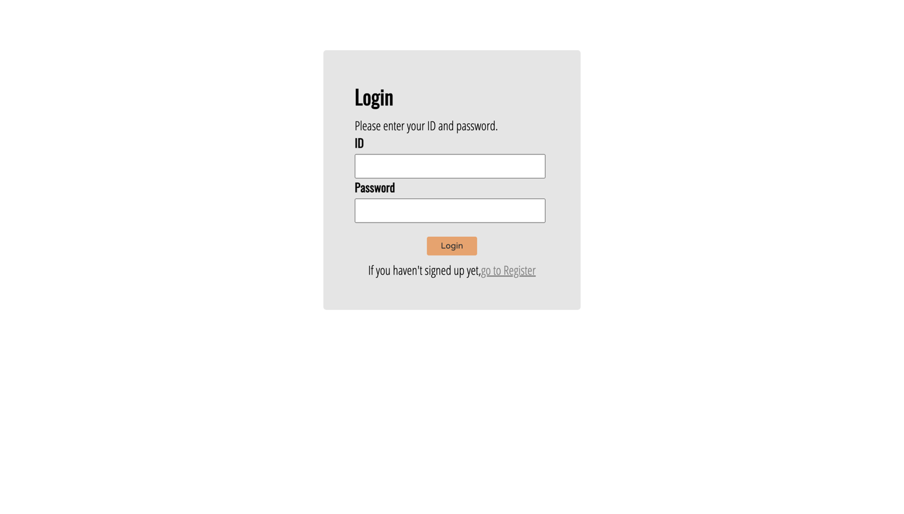

[Main Function]

* In the login page, the user may log in with the account information registered therein.
* Login title: This indicates that the page is a login page.
* Introduction to login method: You can see that you can login by entering your accounts information.
* You have to write the following in order to register.
  1. ID: You have to enter your own ID.
  2. password: you must enter a password connected to the ID.
  3. If there is a blank in the form above, a warning phrase appears.
* Login success: When you click the button, if you have an account where the ID and password match, you can succeed in login.
* If you want to go to the register page, you can go to the login page by clicking 'go to register'.

# For Administrator – Manage member List

## [Calendar Page]

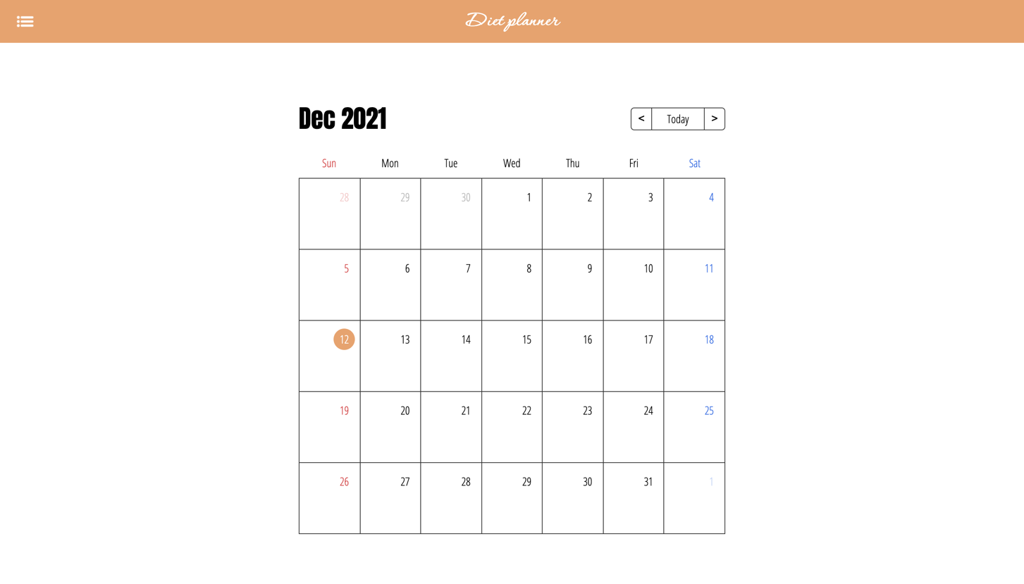

[Main Function]

* Check Monthly: On the register page, you can check this month's calendar page. Saturday and Sunday can be intuitively checked by setting a color that stands out.
* Go to last month/next month: You can also view the calendar for this month/last month by clicking the nav button on the calendar.
* Go to Today: You can easily return to this month by clicking the today button even when you are looking at the other month.
* Check Today: Go to daily: When you click on one of the month, go to the daily page of that date.

## [Daily Page]

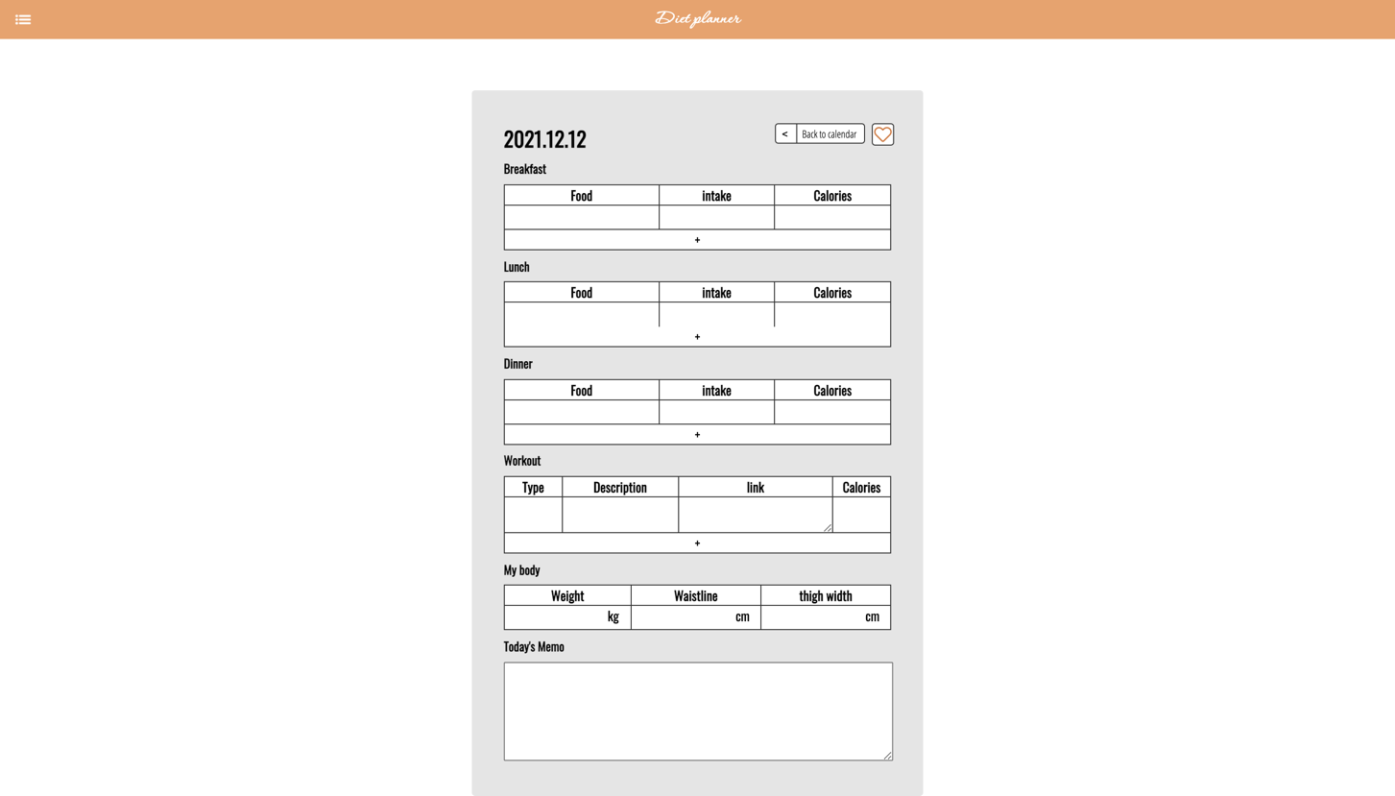

[Main Function]

* Back to calendar: You can click this button to return to the calendar page.
* Diet Management: You can manage your breakfast, lunch, and dinner diets with the following items. What you wrote can be saved and checked the next time you enter the daily page of this day.
  1. Food: The type of food you eat.
  2. Inake: The amount of food you eat. You don't have to fill out this item.
  3. Calories: The total calories of the food you consume.
* Exercise management: You can manage your exercise life in the following items.
  1. Type: The type of exercise you did.
  2. Description: A detailed description of your exercise. You don't have to fill out this item.
  3. link: a video or something you referenced. You don't have to fill out this item.
  4. Calories: The total calories you consume from this exercise.
* Body information management: You can record body information that varies from day to day: weight, waist line, thigh width.
* Diary Writing: You can write down a simple memo or what you felt today. This can be seen next time you enter the daily page of this day again.
* Designate best day: If you think today is the best day, click the heart button at the top. Today's brief information (intake colors, burned colors, weight, wait) is recorded on the best day page.
* However, it is not stored when the type or calories of food are not recorded in the breakfast, lunch, or dinner tables.
* Also, it is not stored when the type or calories of exercise are not recorded on the exercise table.

## [Best day Page]

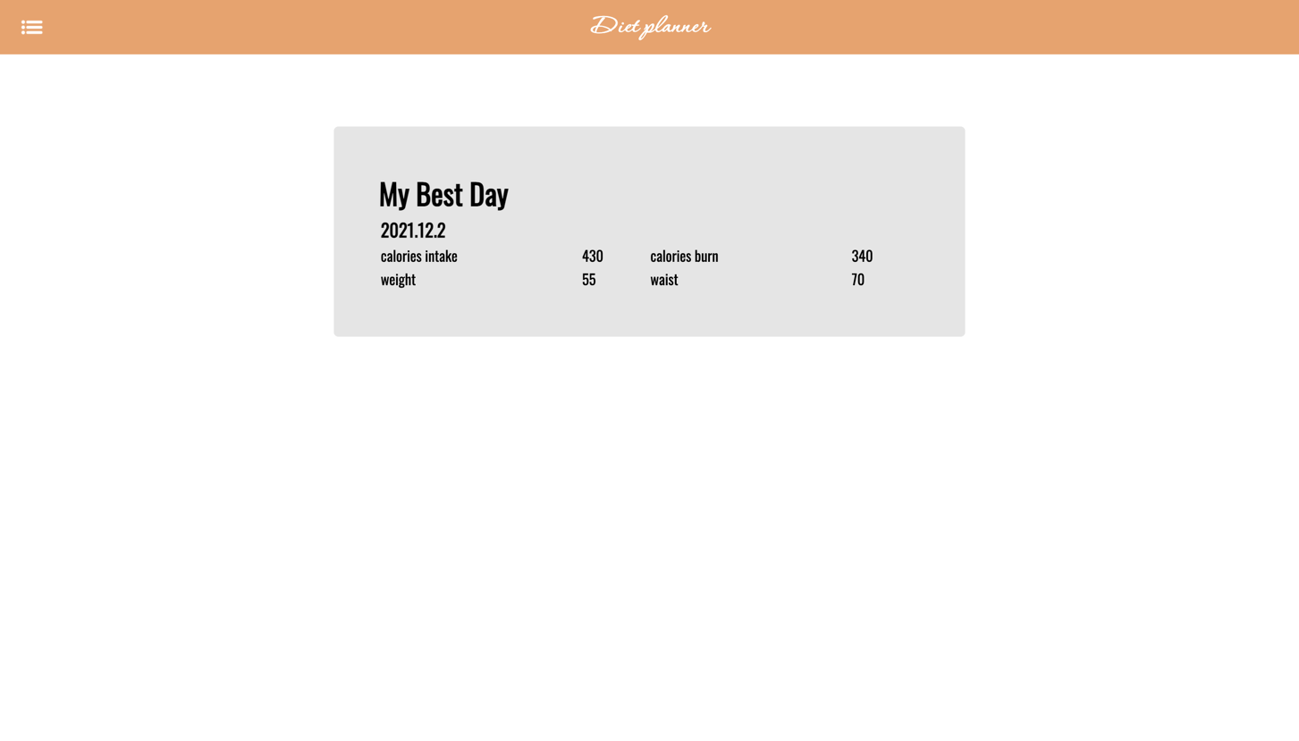

[Main Function]

* Best day confirmation: When you click the heart button on the daily page, it is saved as a table on this page. You can check what the intake colors, burn colors, weight, and wait line of the day were like. Every time a button is clicked, it is added below in the form of table.

## [Mypage Page]

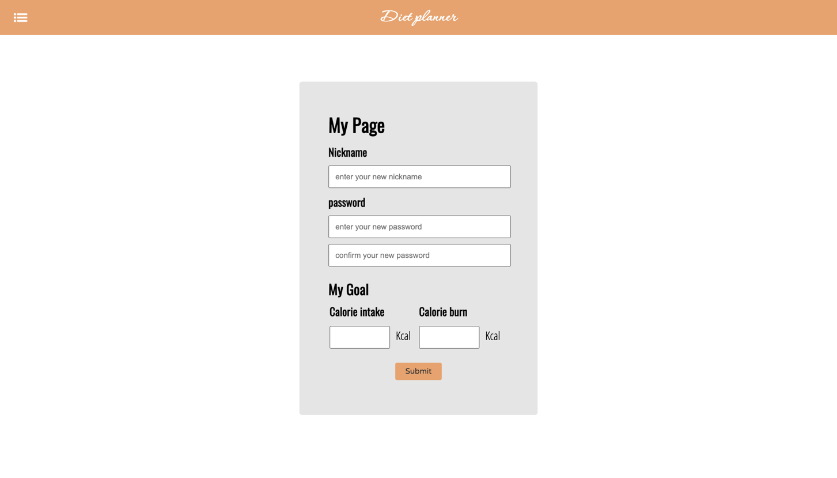

[Main Function]

* Modify member information: you can modify the nickname and password in mypage. When you click the button, the modified information is saved.
* Modify my goals: You can modify goals in my page: Intake caloriers and burn calories goals of the day.

## [Menu Page]

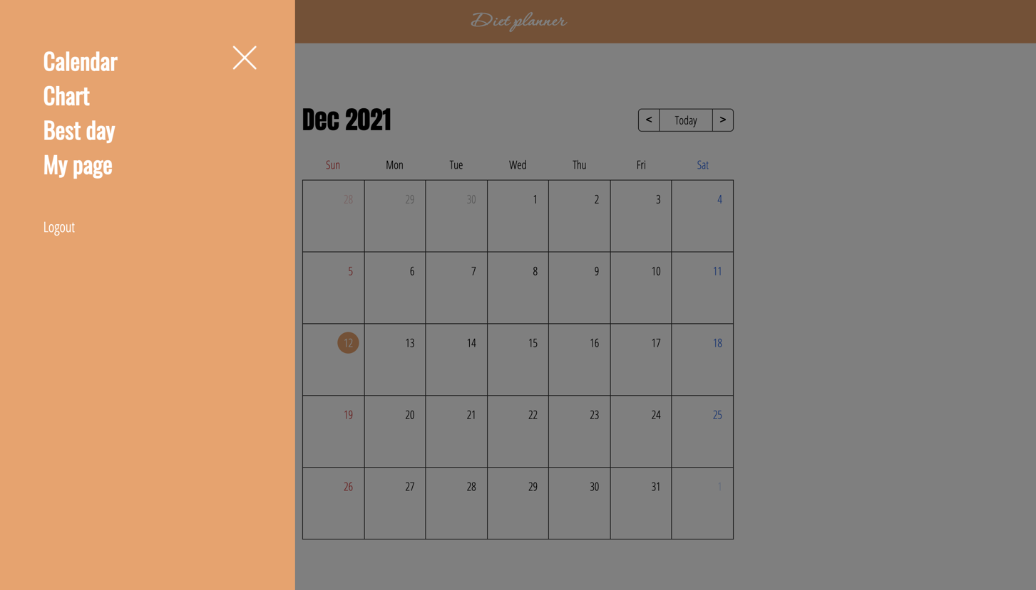

[Main Function]

* Sliding Menu: When you click the menu icon of the header, the menu appears. At this time, the menu appears sliding from left to right for 0.3 seconds with a slide effect.
* Page Movement: You can select and move the desired page.
* Logout: Click Logout to go to the initial page.

# Database with Javascript

Backend was implemented through JavaScript. The necessary data was stored in JavaScript through an arrangement.

# Instruction

All the files for executing my project are in the folder. Among them, start the server of the main.html file.

